Special Educational Needs (SEN) Information Report
Reffley Academy

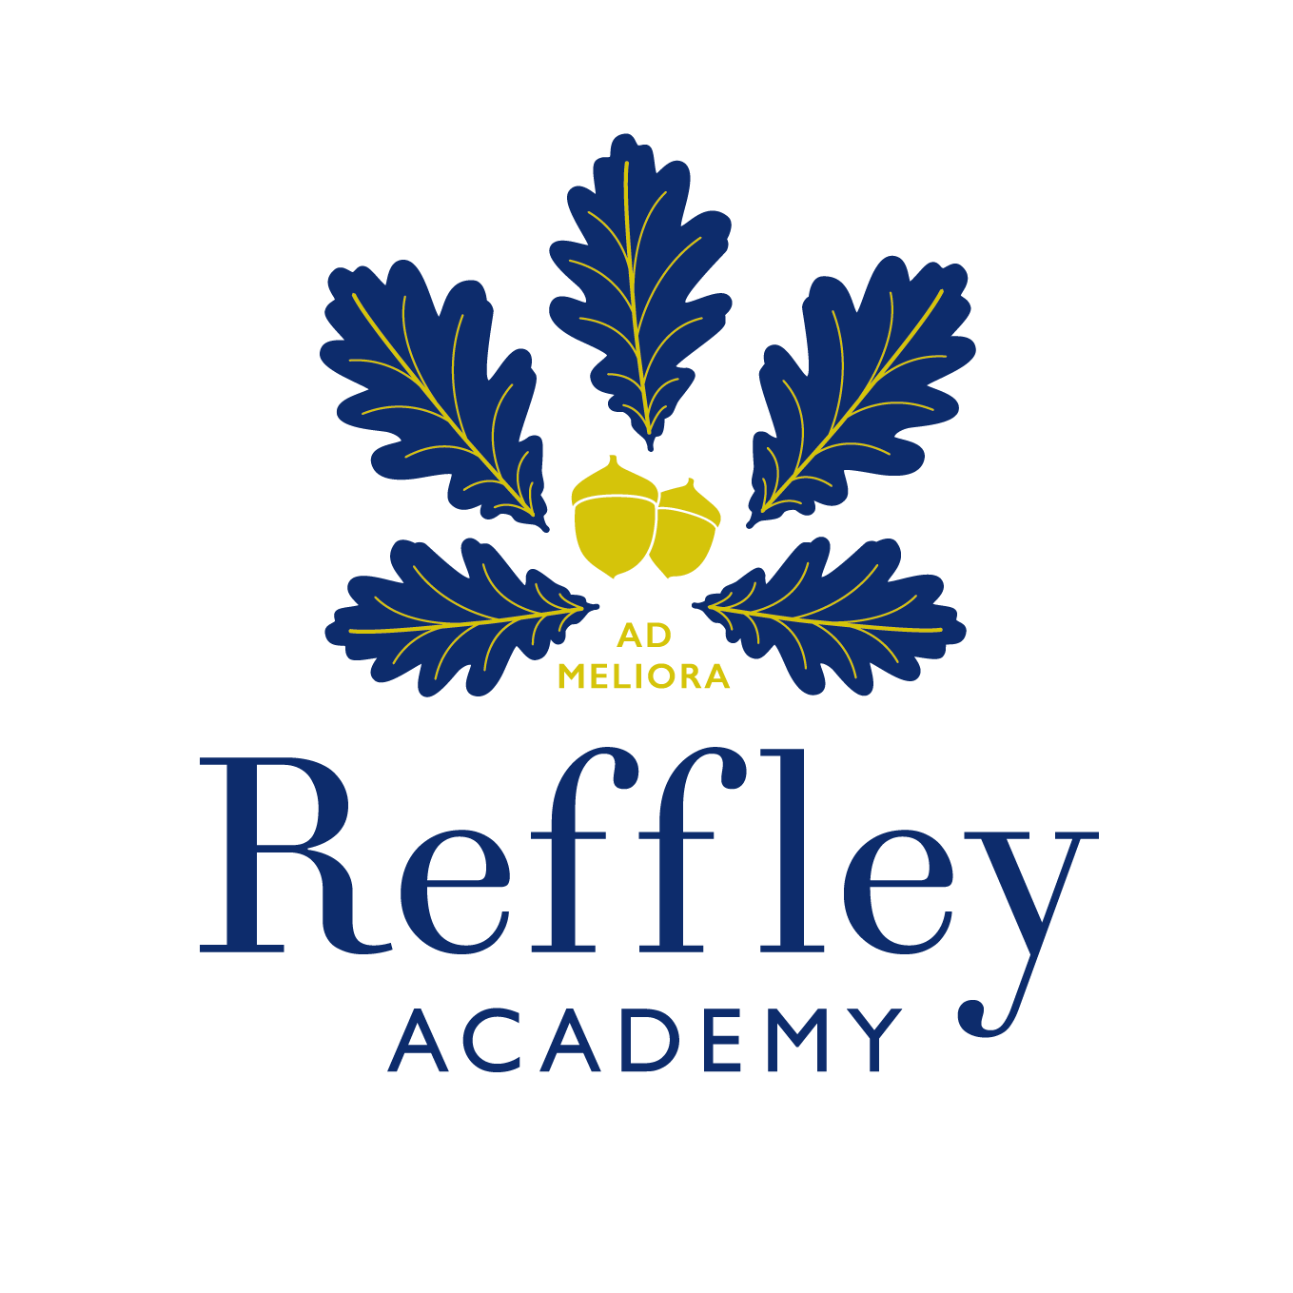

Document Detail
Category | Statutory
Department | Academies within the Trust
Responsible Officer | Headteacher
Approved by: | Directors  Resources, Risk and Audit committee  Chief Executive Officer  Academy Committee
Status
Reviewed on: | Term 1 – 2025/26
Next review: | Term 1 -2026/27

Contents
1. What types of SEN does the academy provide for? 3
2. Which staff will support my child, and what training have they had? 3
3. What should I do if I think my child has SEN? 4
4. How will the academy know if my child needs SEN support? 5
5. How will the academy measure my child’s progress? 6
6. How will I be involved in decisions made about my child’s education? 6
7. How will my child be involved in decisions made about their education? 7
8. How will the academy adapt its teaching for my child? 7
9. How will the academy evaluate whether the support in place is helping my child? 9
10. How will the academy resources be secured for my child? 9
11. How will the academy make sure my child is included in activities alongside pupils who don’t have SEN? 9
12. How does the academy make sure the admissions process is fair for pupils with SEN or a disability? 10
13. How does the academy support pupils with disabilities? 10
14. How will the academy support my child’s mental health and emotional and social development? 10
15. What support will be available for my child as they transition between classes or settings or in preparing for adulthood? 10
16. What support is in place for looked-after and previously looked-after children with SEN? 11
17. What should I do if I have a complaint about my child’s SEN support? 11
18. What support is available for me and my family? 12
19. Glossary 12

Dear Parents and Carers,
Welcome to our SEN information report. This document is part of the Norfolk Local Offer for learners with Special Educational Needs (SEN). The local offer is an online resource designed to support children and young people with special educational needs/ disabilities and their families. It describes the services and provision available within Norfolk for all children with special needs/ disabilities with or without an Education Health and Care Plan (EHCP). The Norfolk Local Offer can be found here; https://www.norfolk.gov.uk/children-and-families/send-local-offer

The aim of this SEN information report is to explain how we implement our SEND policy. In other words, we want to show you how special educational needs support works in our academy.

This report is reviewed annually, and should be read in conjunction with our SEN policy and our SEN Accessibility Plan. You can find both documents on our website https://www.reffley.norfolk.sch.uk or you can ask a member of staff to send you a hard copy. This report should tell you all you need to know about SEN at our academy. If you do have any questions, please contact us and we will be happy to help.

Our Headteacher is Miss Helen Fendley head@reffley.norfolk.sch.uk.
Our SENCO is Mrs Lisa Lee Llee@reffley.norfolk.sch.uk.
Academy office 01553 671045 or email office@reffley.norfolk.sch.uk.

Note: If there are any terms we’ve used in this information report that you’re unsure of, you can look them up in the glossary at the end of the report.

1. What types of SEN does the academy provide for?
Our academy provides for pupils with the following needs: -

Area of need | Condition
Communication and interaction | Autism spectrum disorder (ASD)
Communication and interaction | Speech and language difficulties
Cognition and learning | Specific learning difficulties, including dyslexia, dyspraxia, dyscalculia
Cognition and learning | Moderate learning difficulties
Cognition and learning | Severe learning difficulties
Social, emotional and mental health | Attention deficit hyperactivity disorder (ADHD)
Social, emotional and mental health | Attention deficit disorder (ADD)
Sensory and/or physical | Hearing impairments
Sensory and/or physical | Visual impairment
Sensory and/or physical | Multi-sensory impairment
Sensory and/or physical | Physical impairment

2. Which staff will support my child, and what training have they had?
Our special educational needs co-ordinator, or SENCO
Our SENCo is Mrs Lisa Lee and she can be contacted by phone on 01553 671045 or by emailing Llee@reffley.norfolk.sch.uk. Mrs Lee has worked at Reffley Academy for the last 8 years and is a qualified teacher. She is working towards achieving the National Professional Qualification for Special Educational Needs Coordinators. Mrs Lee is based full-time in the academy to manage SEN provision.

Pastoral support in the academy
Our Family Support Advisor is Miss Claire Hodgson and she can be contacted on 01553 671045 or by emailing chodgson@reffley.norfolk.sch.uk. Miss Hodgson is available full-time in the academy to provide pastoral support, behavioural support at both the academy and at home, referrals to mental health services and can signpost parents/carers to relevant support from external agencies where necessary.

Class Teachers
All of our teachers receive in-house SEN training, and are supported by the SENCo to deliver high-quality teaching to meet the needs of all pupils including those who have SEN. Continuous professional development is also supported by external SEN training including training from the educational psychology service, speech and language therapists, the Dyslexia Outreach Service and the Autism Education Trust.

Teaching assistants (TAs)
We have a team of TAs, including one higher-level teaching assistant (HLTA), who are trained to deliver SEN interventions, for example precision teaching, interventions based on the principles of Attention Autism, colourful semantics and recommendations from the Dyslexia Outreach Service.

External agencies and experts
Sometimes we need extra help to offer our pupils the support they need. Whenever necessary we will work with external support services to meet the needs of our pupils with SEN and to support their families. These include: -
- Speech and language therapists
- Educational psychologists
- Occupational therapists
- GPs or paediatricians
- School nurses
- Virtual Schools Sensory Support team
- Access through Technology
- School to School
- Early Help
- Schools and Inclusion team
- Specialist Resource Bases (SRBs)
- Mental Health in Schools team (MHST)
- Child and adolescent mental health services (CAMHS)
- Education welfare officers
- Social services and other local authority (LA)-provided support services
- Voluntary sector organisations
- Dyslexia Outreach Service (DOS)
- Autism Education Trust (AET)

3. What should I do if I think my child has SEN?
At Reffley Academy, we are committed to working together with all members of our academy community.

We believe children are best supported where there is open dialogue between home and the academy, where both sets of expertise are used in the best interests of the child. As parents/carers, you can always speak to your child’s class teacher or our SENCo about any concerns you may have. We offer a friendly, caring and inclusive environment where social and emotional support is of great importance to developing the whole child.

If you think that your child may have a special educational need, please speak to the class teacher in the first instance. They can meet with you to discuss your concerns and try to get a better understanding of what your child’s strengths and difficulties are. Together, we will decide what outcomes to seek for your child and agree on next steps. The class teacher will inform our academy SENCo who will be in touch to discuss your concerns or you can contact the SENCo directly. If we decide that your child needs SEN support, we will formally notify you and confirm your child will be added to the academy’s SEN register.

If you think your child might have SEN, the first person you should tell is your child’s teacher.  You can get in touch with your child’s class teacher by asking to make an appointment, sending a message on class dojo or by telephoning the academy office and requesting a call back.  They will pass the message on to our SENCO, Mrs Lisa Lee, who will be in touch to discuss your concerns.  You can also contact the SENCO directly by calling the academy office or emailing:  Llee@reffley.norfolk.sch.uk. | We will meet with you to discuss your concerns and try to get a better understanding of what your child’s strengths and difficulties are.  Together we will decide what outcomes to seek for your child and agree on next steps.  We will make a note of what’s been discussed and add this to your child’s record. You can request a copy of this record in writing if required. | If we decide that your child needs SEN support, we will create a SEN support plan (APDR) which will be shared with you. Your child will be added to the academy’s SEND register.

4. How will the academy know if my child needs SEN support?
All our class teachers are aware of SEN and are on the lookout for any pupils who aren’t making the expected level of progress. This may be in their schoolwork and include reading, writing or number work; or socially which may include interactions or collaborative working with peers, or during unstructured times during the school day.

If the teacher notices that a pupil is falling behind, they try to find out if the pupil has any gaps in their learning. If they can find a gap, they will give the pupil extra tuition to try to fill it. Pupils who don’t have SEN usually make progress quickly once the gap in their learning has been filled.

If the pupil is still struggling to make the expected progress, the teacher will talk to the SENCO, and will contact you to discuss the possibility that your child has SEN.

The SENCO will observe the pupil at times during the school day to see what their strengths and difficulties are. They will have discussions with your child’s teacher/s, to see if there have been any issues with, or changes in, their progress, attainment or behaviour. They will also compare your child's progress and development with their peers and available national data.

The SENCO will ask for your opinion and speak to your child to get their input as well. They may also, where appropriate, ask for the opinion of external experts such as a speech and language therapist, an educational psychologist, or a paediatrician.
Based on all of this information, the SENCO will decide whether your child needs SEN support and you will be told the outcome of the decision. If your child does need SEN support, their name will be added to the academy’s SEND register, and the SENCO will work with you to create a SEN support plan for them.

Sometimes, the needs of the child may be complex and/or significant. There may be a need for the academy to apply for an Education, Health and Care Plan (EHCP) needs assessment.

More information about the EHCP process can be found on the Local Offer website. Professionals from education, health or care sectors can apply for an EHCP.

5. How will the academy measure my child’s progress?
We will follow the ‘graduated approach’ to meeting your child’s SEN needs. The graduated approach is a 4-part cycle of assess, plan, do, review (APDR) and helps us create an effective SEN support plan.

Review
We will assess how well the support we put in place helped the child to meet the outcomes we set. We will use our improved understanding of
your child’s needs to improve the support we offer.
Assess
If your child is not making the expected level of progress, we will make an assessment to find out what strengths and difficulties your child has. We will ask for input from you and your child, as well as getting help from external professionals where necessary.

Plan
In discussion with you and your child, we will decide what outcomes we are hoping to achieve. We will make a plan of the support we will offer your child to help them meet those outcomes. We will make a record of this and share it with you and all relevant academy staff.
Do
We will put our plan into practice.
The class teacher, with the support of the SENCO, will be responsible for working with your child on a daily basis, and making sure the support we put in place is having the impact we intended.

As a part of the planning stage of the graduated approach, we will set outcomes that we want to see your child achieve.

Whenever we run an intervention with your child, we will assess them before the intervention begins. This is known as a ‘baseline assessment’. We do this so we can see how much impact the intervention has on your child’s progress.

We will track your child’s progress towards the outcomes we set over time and improve our offer as we learn what your child responds to best.

This process will be continual. If the review shows a pupil has made progress, they may no longer need the additional provision made through SEN support. For others, the cycle will continue and the academy's targets, strategies and provisions will be revisited and refined.

6. How will I be involved in decisions made about my child’s education?
We will provide an annual report on your child's progress at the end of the summer term.

Your child’s class teacher will also meet you at least twice a year to: -
- Set clear outcomes for your child’s progress
- Review progress towards those outcomes
- Discuss the support we will put in place to help your child make that progress
- Identify what we will do, what we will ask you to do, and what we will ask your child to do

The SENCO may also attend these meetings to provide extra support.

We know that you’re the expert when it comes to your child’s needs and aspirations. We want to make sure you have a full understanding of how we’re trying to meet your child’s needs, so that you can provide insight into what you think would work best for your child.

We also want to hear from you as much as possible so that we can build a better picture of how the SEN support we are providing is impacting your child outside of the academy.

If your child’s needs or aspirations change at any time, please let us know right away so we can keep our provision as relevant as possible.

After any discussion we will make a record of any outcomes, actions and support that have been agreed. This record will be shared with all relevant staff, and you will be given a copy.

If you have concerns that arise between these meetings, please contact your child’s class teacher

7. How will my child be involved in decisions made about their education?
The level of involvement will depend on your child’s age and level of competence. We recognise that no two children are the same, so we will decide on a case-by-case basis, with your input.

We may seek your child’s views by asking them to: -
- Attend meetings to discuss their progress and outcomes
- Prepare a written statement, drawing, etc.
- Discuss their views with a member of staff who can act as their representative.
- Help create a one-page profile including important things they would like to share with staff in the academy and their aspirations for the future.

8. How will the academy adapt its teaching for my child?
Your child’s class teacher/s is/are responsible and accountable for the progress and development of all the pupils in their class including those with SEN.

We value high quality teaching for all learners and actively monitor teaching and learning in the academy. We aim to create a learning environment, which is flexible enough to meet the needs of all learners, and monitor the progress of all pupils to ensure that effective learning is taking place. We ensure that all pupils in our academy are equally valued by having access to a broad and balanced curriculum, which is differentiated to meet individual needs. We aim to balance high expectations with support, ensuring we are ambitious for every pupil whilst acknowledging their needs, so all pupils have the opportunity to experience meaningful success.

We will differentiate (or adapt) how we teach to suit the way the pupil works best. There is no 'one size fits all’ approach to adapting the curriculum, we work on a case-by case basis to make sure the adaptations we make are meaningful to your child.

These adaptations can include: -
- Differentiating our curriculum to make sure all pupils are able to access it, for example, by grouping, 1-to-1 work, adapting the teaching style or content of the lesson, etc.
- Differentiating our teaching, for example, giving longer processing times, pre-teaching of key vocabulary, reading instructions aloud, etc.
- Adapting our resources and staffing
- Using recommended aids, such as laptops, coloured overlays, visual timetables, larger font, etc.
- Teaching assistants will support pupils on a 1-to-1 basis or in small groups when delivering targeted interventions. We take into the account the separation effect when planning these targeted interventions to minimise the amount of time pupils with SEN are apart from their teachers and peers.

We may also provide the following interventions: -
Area of need | Condition | How we support these pupils
Communication and interaction | Autism spectrum disorder (ASD) | Visual timetables/visual support  Now/next boards  Social stories  Intensive Interaction  Attention Autism
Communication and interaction | Speech and language difficulties | Speech and language interventions based on recommendations from speech and language therapists.  Makaton  Augmentative and alternative communication systems including core boards and ICT
Cognition and learning | Specific learning difficulties, including dyslexia, dyspraxia and dyscalculia | Writing slope  Coloured overlays  Dyslexia/dyscalculia friendly classrooms
Cognition and learning | Moderate or severe learning difficulties | Multi-sensory teaching  Breaking tasks down into more manageable chunks  Simple, clear instructions  Visual aids or prompts  Scaffolding to build independence
Social, emotional and mental health | ADHD, ADD | Quiet workstation  Fidget toys or wobble boards/cushions  Resistance bands  Movement breaks  Sensory diet
Social, emotional and mental health | Adverse childhood experiences and/or mental health issues | Check ins  Nurture groups
Sensory and/or physical | Hearing impairment | Specialist equipment including hearing aids or loops  Consider seating plan & reduce background noise
Sensory and/or physical | Visual impairment | Modification of resources including font type/print size  Organisation of environment/seating plan  Assistive technology  Verbal information
Sensory and/or physical | Sensory processing difficulties | Sensory diet  Sensory circuits
Sensory and/or physical | Physical impairment | Environment modifications  Learning aids and/or assistive technology

These interventions are part of our contribution to Norfolk County Council’s SEND local offer.

9. How will the academy evaluate whether the support in place is helping my child?
We will evaluate the effectiveness of provision for your child by: -
- Reviewing their progress towards their goals each term.
- Reviewing the impact of interventions at least half-termly.
- Monitoring by the SENCO
- Holding an annual review (if they have an education, health and care (EHC) plan)

10. How will the academy resources be secured for my child?
It may be that your child’s needs mean we need to secure: -
- Extra equipment or facilities
- More teaching assistant hours
- Further training for our staff
- External specialist expertise

If that’s the case, we will consult with external agencies to get recommendations on what will best help your child access their learning.

The academy will cover up to £6,000 of any necessary costs. If funding is needed beyond this, we will discuss this at our termly Team Around the School meeting attended by representatives from the local authority.

11. How will the academy make sure my child is included in activities alongside pupils who don’t have SEN?
All schools have duties under the Equality Act 2010 towards individual disabled children and young people. This means all of our extra-curricular activities and school visits are available to all our pupils, including our before and after-school clubs.

All pupils are encouraged to go on our school trips, including our residential trip in Upper Key Stage 2.

All pupils are encouraged to take part in sports day, school plays or special workshops

We will make whatever reasonable adjustments are needed to make sure they can be included, so no pupil ever feels excluded from taking part in these activities because of their SEN or disability.

12. How does the academy make sure the admissions process is fair for pupils with SEN or a disability?
As an academy, we ensure the admissions process for pupils with Special Educational Needs (SEN) or disabilities is fair by complying with the Equality Act 2010, which mandates schools make reasonable adjustments, prevent less favorable treatment, and have an Accessibility Plan to improve access. For children with an Education, Health, and Care (EHC) plan, when places are allocated priority is given if the child’s EHC plan names our academy, as this is a legal requirement separate from the standard admissions criteria. The SENCO will work closely with prospective parents/carers to discuss provision needed.

13. How does the academy support pupils with disabilities?
Our Trust accessibility plan can be found on our academy website www.reffley.norfolk.sch.uk – look at the section ‘about us’ and then select ‘SEN’. This plan shows the steps we have taken to prevent disabled pupils from being treated less favourably than other pupils. It also includes ways we can increase the extent to which disabled pupils can participate in the curriculum, ways we have improved the physical environment to enable disabled pupils to take better advantage of the education, benefits, facilities and services provided by the academy, and how we can improve the availability of accessible information to disabled pupils.

14. How will the academy support my child’s mental health, and emotional and social development?
Support for pupils to progress in their emotional and social development may be provided in the following ways: -
- We provide extra pastoral support for listening to the views of pupils with SEN – this may be through a key adult or our Family Support Advisor/Pastoral Support Miss Claire Hodgson.
- We run targeted interventions for pupils who need extra support with social or emotional development.
- External advice can be sought from/referrals can be made to external agencies including the Mental Health in Schools Team (MHST) or Child and Adolescent Mental Health Services (CAMHS).

We have a zero-tolerance approach to bullying. Bullying is defined as the repetitive, intentional harming of one person or group by another person or group, where the relationship involves an imbalance of power. Bullying is therefore: -
- Deliberately hurtful
- Repeated, often over a period of time
- Difficult to defend against

Our academy’s approach to preventing and addressing bullying are set out in our Policy for Inclusion and Behaviour which is available to view on our website www.reffley.norfolk.sch.uk.

15. What support will be available for my child as they transition between classes or settings, or in preparing for adulthood?
Between years
To help pupils with SEN be prepared for a new school year we: -
- Ask both the current teacher and the next year’s teacher to attend a final meeting of the year when the pupil’s SEN is discussed including the latest cycle of a SEN support plan (APDR).
- A transition document is shared by the current teacher including attainment, provision provided, effective strategies and any other information that will help a pupil make a successful transition to their new year group.
- Extra visits to new classroom and to meet the next year’s teacher will be scheduled towards the end of the summer term in addition to the move up days.

Between schools
When your child is moving on from our academy, we will ask you and your child what information you want us to share with the new setting.

Between phases
We will invite the SENCO of the secondary school to come into our academy for a meeting or schedule a video call with our SENCO. They will discuss the needs of all the children who are receiving SEN support. If a child has an EHCP, the SENCO of the secondary school will also be invited to the EHCP annual review.

Pupils may also be prepared for the transition by attending extra transition days if offered by the secondary school.

16. What support is in place for looked-after and previously looked-after children with SEN?
Our designated teacher for looked-after children and previously looked-after children is our SENCO, Mrs Lisa Lee. The role of the designated teacher is to make sure that all teachers understand how a looked-after or previously looked-after pupil’s circumstances and their SEN might interact, and what the implications are for teaching and learning.

Children who are looked-after or previously looked-after will be supported much in the same way as any other child who has SEN. However, looked-after pupils will also have a personal education plan (PEP). We will make sure that the PEP and any SEN support plans or EHC plans are consistent and complement one another.

17. What should I do if I have a complaint about my child’s SEN support?
If you are unhappy with the support your child is getting, you should discuss your concerns with the class teacher first. Teachers and parents/carers working together can often provide solutions to any concerns you may have. If you are still unhappy, you should contact the academy office to get a copy of the Trust’s complaints procedure. Our complaints policy can be found on our website www.reffley.norfolk.sch.uk.

If you are not satisfied with the academy’s response, you can escalate the complaint. In some circumstances, this right also applies to the pupil themselves.

To see a full explanation of suitable avenues for complaint, see pages 246 and 247 of the SEND Code of Practice.

If you feel that our academy has discriminated against your child because of their SEN, you have the right to make a discrimination claim to the first-tier SEND tribunal. To find out how to make such a claim, you should visit: https://www.gov.uk/complain-about-school/disability-discrimination

You can make a claim about alleged discrimination regarding: -
- Admission
- Exclusion
- Provision of education and associated services
- Making reasonable adjustments, including the provision of auxiliary aids and services

Before going to a SEND tribunal, you can go through processes called disagreement resolution or mediation, where you try to resolve your disagreement before it reaches the tribunal.

Further support is available from the Norfolk SENDIASS service www.norfolksendiass.org.uk who can provide free and impartial information, advice and support for parents/carers of children with special educational needs. This includes support services for parents/carers pursuing mediation.

If your child has an Education, Health and Care Plan, you can also contact your Special Educational Needs

18. What support is available for me and my family?
If you have questions about SEN, or are struggling to cope, please get in touch to let us know. We want to support you, your child and your family.

To see what support is available to you locally, have a look at Norfolk County Council’s local offer, information is published on their website https://www.norfolk.gov.uk/article/40393/SEND-Local-Offer.

Information and advice are also available from Just One Norfolk https://www.justonenorfolk.nhs.uk or you can ring the local authority SEND and Inclusion line on 0333 313 7165.

Our local special educational needs and disabilities information, advice and support (SENDIAS) services can be found at www.norfolksendiass.org.uk.

National charities that offer information and support to families of children with SEN are: -
IPSEA
SEND family support
NSPCC
Family Action
Special Needs Jungle

19. Glossary
- Access arrangements – special arrangements to allow pupils with SEN to access assessments or exams
- Annual review – an annual meeting to review the provision in a pupil’s EHC plan
- Area of need – the 4 areas of need describe different types of needs a pupil with SEN can have. The 4 areas are communication and interaction; cognition and learning; physical and/or sensory; and social, emotional and mental health needs
- CAMHS – child and adolescent mental health services
- Differentiation – when teachers adapt how they teach in response to a pupil’s needs
- EHC needs assessment – the needs assessment is the first step on the way to securing an EHC plan. The local authority will do an assessment to decide whether a child needs an EHC plan
- EHC plan – an education, health and care (EHC) plan is a legally-binding document that sets out a child’s needs and the provision that will be put in place to meet their needs
- First-tier tribunal / SEND tribunal – a court where you can appeal against the local authority’s decisions about EHC needs assessments or plans and against discrimination by a school or local authority due to SEN
- Graduated approach – an approach to providing SEN support in which the school/academy provides support in successive cycles of assessing the pupil’s needs, planning the provision, implementing the plan, and reviewing the impact of the action on the pupil
- Intervention – a short-term, targeted approach to teaching a pupil with a specific outcome in mind
- Local offer – information provided by the local authority that explains what services and support are on offer for pupils with SEN in the local area
- Outcome – target for improvement for pupils with SEN. These targets don't necessarily have to be related to academic attainment
- Reasonable adjustments – changes that the school/academy must make to remove or reduce any disadvantages caused by a child’s disability
- SENCO – the special educational needs co-ordinator
- SEN – special educational needs
- SEND – special educational needs and disabilities
- SEND Code of Practice – the statutory guidance that schools and academies must follow to support children with SEND
- SEN information report – a report that schools and academies must publish on their website, that explains how the school/academy supports pupils with SEN
- SEN support – special educational provision that meets the needs of pupils with SEN
- Transition – when a pupil moves between years, phases, schools/academies or institutions or life stages

